Programming the FPGA
Quartus Prime 18.1

Using Pin Planner:
- Make sure your design has already been successfully synthesized.
NOTE: If you have done a full compilation, the pins may be auto-assigned and you may encounter problems in the following steps. If that occurs, go to Assignments > Remove, select “All” and then follow the steps below.
- Click Assignments > Pin Planner
- Enter a pin number in the Location column for each of the inputs and outputs. You can find pin numbers in your DE10-Lite user manual (Or the DE10-Lite pin assignment quick reference document on Canvas). Pin assignments are determined by your dev board, not by the FPGA itself. The signal names are listed below – use the pin assignment reference to confirm the pin locations.
  - Assign node a to SW0
  - Assign node b to SW1
  - Assign node s to LEDR0
  - Assign node c to LEDR1
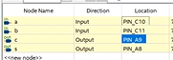
- Save and close the Pin Planner.
- Fully compile the design. Double-click Compile Design in the left-hand Task pane.
- All tasks in the Task pane should now have green checkmarks.

Programming the board:
- Connect the FPGA to your computer using the provided USB cable.
- Open Device Manager and search for USB-Blaster. If the caution sign is next to the device icon, the drivers will need to be installed. If there is no caution sign, skip to step 4.
  - For Mac users working on a Virtual Machine: When connecting the DE10-Lite, ensure that the DE10-Lite is added to the list of USB device filters, under VirtualBox Manager > Settings > Ports > USB. Click the USB icon with a “+” to the right of the box labeled “USB Device Filters” and select the USB-Blaster.
- Navigate to the directory where Quartus is installed (C:\intelFPGA_lite\18.1\quartus\drivers). In this directory, run the DPInst application (see figure below). After the install wizard is complete, the driver should be installed and the Altera USB Blaster should be listed under Universal Serial Bus controllers in the Device Manager.
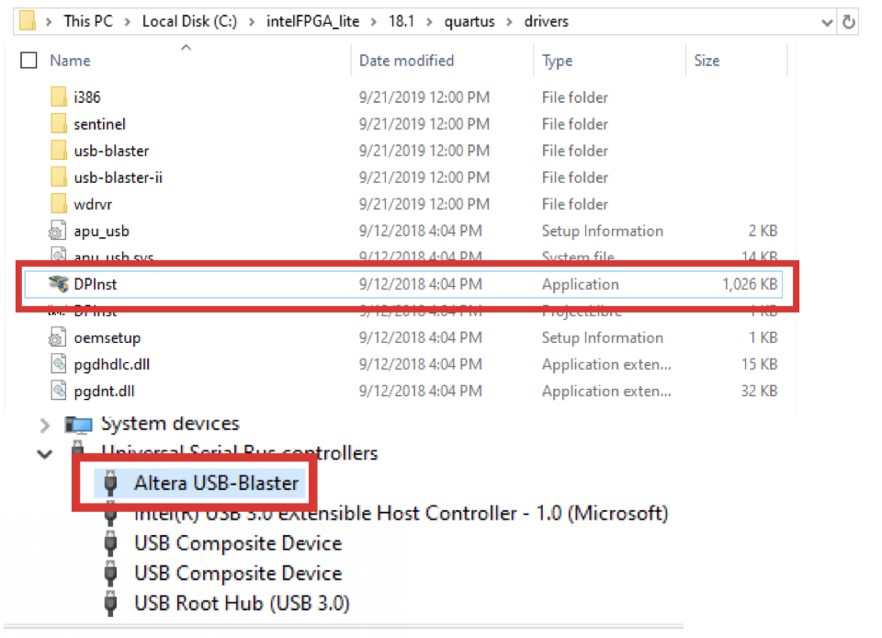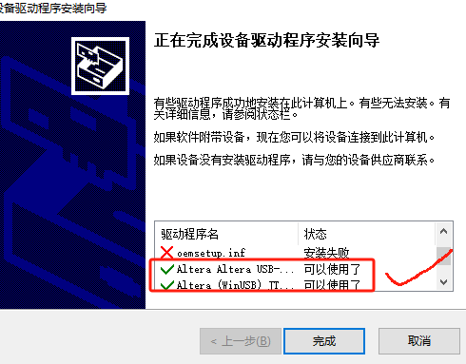
- In Quartus, go to Tools > Programmer to open the Programmer window. Next to the Hardware Setup button, the field should display No Hardware. If it displays USB-Blaster, skip to step 6.
- Click the Hardware Setup button to open the hardware setup window. In the Currently Selected Hardware drop-down menu, select USB-Blaster, then click Close. Verify that the Hardware Setup field now shows USB-Blaster.
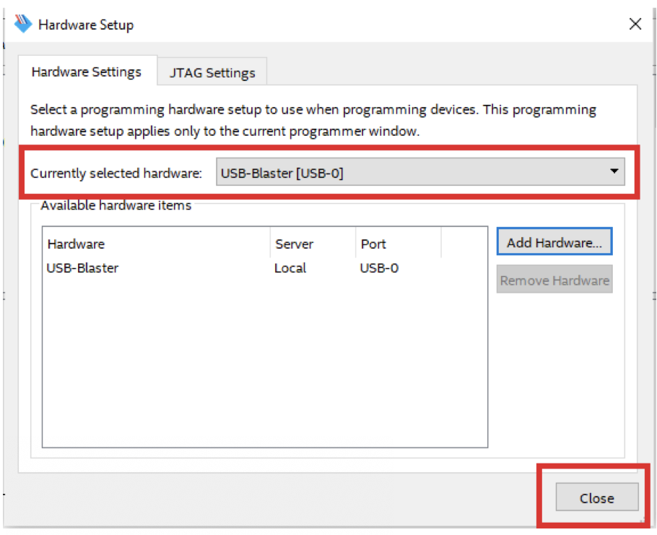
- In the programmer window, select the output file corresponding to the project, then click Start to download to the FPGA. Verify that download completes successfully.
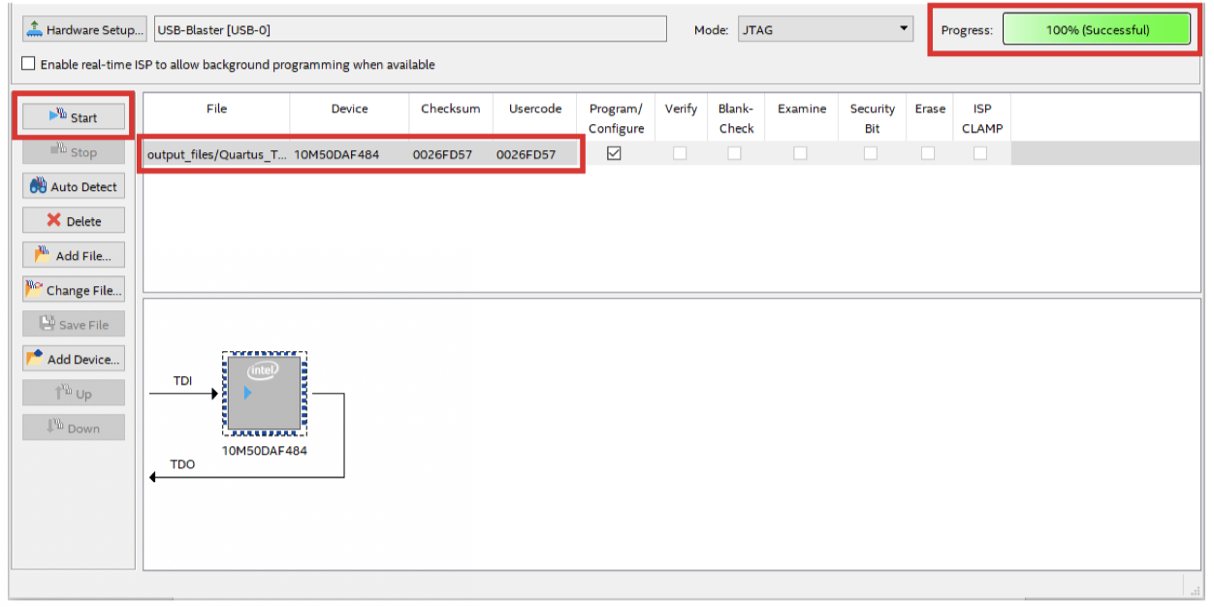
- Test out your half adder by flipping the switches SW0 and SW1 on your FPGA board.

